Let’s take an ordinary life example: reading a book

Suppose I am laying down on my bed and reading a book. It is getting late and the sun goes down. The light is getting dimmer and I feel the need to get more light, otherwise it becomes hard to read.

**1. Goal**

My current activity is reading, but my goal becomes: I need more light to be able to see.

**2. Planning**

How do I do that? I have many choices: **a)** I can open the curtains for more light; **b)** Turn on a nearby light; **c)** Or leave the book for tomorrow morning. In the planning stage I analyse all the possible scenarios I could take to achieve my goal. Let’s say I choose to turn on a nearby light.

**3. Specify**

But even then I have to decide how I do it. Do I ask someone? Do I do it myself?

**4. Perform**

And finally I must execute, meaning I go and turn on the light myself.

If I did this kind of activity before, most of my actions will be subconcious. But if I am not skilled enough, I have to go through a learning curve and all my actions will be concious.

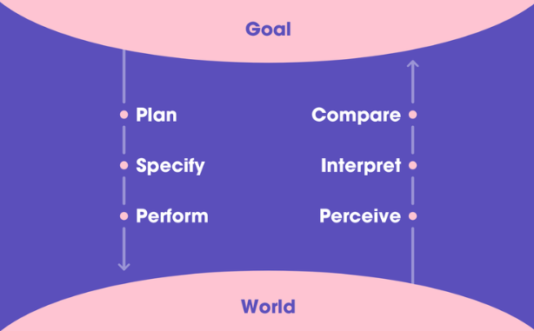

The seven stages of action are a bridge between what we would like to do and all the possible actions to achieve our goal. As mentioned above, you saw only four. Because the rest, three of them, depend on the context. This divides the actions into 2 parts, conscious and subconscious.

**The Goal is the first step in the process.** After we set a goal in our mind, we must do it. There are three stages of execution:

1. **Plan** (the action)
2. **Specify** (an action sequence)
3. **Perform** (the action sequence)

After we performed the actions to achieve our goal, our mind evaluates the situation. And it follows these 3 steps:

1. **Perceiving** what happened
2. **Interpreting** what happened
3. **Compare** the outcome with the goal

This is a simplified version of how our mind works.